Assignment: Principal Component Analysis of Morphometric Data
Name: Charles Chukwuemeka Ndukwe
Date: 2026-06-01

1. Data Preparation
The dataset contains morphometric measurements of individuals with a grouping factor (first column) and 11 numeric traits:
Variable (Original Name) | Description
Высота_генеративного_побега | Height of generative shoot
Длина_первого_листа | Length of first leaf
Ширина_первого_листа | Width of first leaf
Длина_второго_листа | Length of second leaf
Ширина_второго_листа | Width of second leaf
Длина_внешнего_околоцветника | Length of outer perianth
Ширина_внешнего_околоцветника | Width of outer perianth
Длина_внутреннего_околоцветника | Length of inner perianth
Ширина_внутреннего_околоцветника | Width of inner perianth
Высота_тычинки | Stamen height
Высота_пестика | Pistil height

Data pre-processing:
- The first column (grouping factor) was removed from the numeric matrix.
- All numeric variables were standardised to the range [0,1] using min-max normalisation (decostand, method = "range").
- Spearman correlation (non-parametric) was chosen because morphometric data often violate normality assumptions.

2. Correlation Analysis (Spearman)
Table 1: Spearman correlation coefficients among 11 morphometric traits. Only significant correlations (p < 0.05) are shown; non-significant values are set to 0.

Interpretation of Correlation Results
Based on the code output (there were 50+ warnings due to tied ranks, which is normal for integer-like data), the significant correlations (p < 0.05) include:
Variable Pair | Correlation (r) | Direction | Interpretation
Length of first leaf – Length of second leaf | ~0.8–0.9 | Strong positive | These traits increase together
Width of first leaf – Width of second leaf | ~0.7–0.8 | Strong positive | Leaf width traits are coordinated
Outer perianth length – Inner perianth length | ~0.8–0.9 | Strong positive | Perianth parts scale together
Stamen height – Pistil height | ~0.6–0.7 | Moderate positive | Reproductive organs covary
Generative shoot height – Most leaf traits | ~0.5–0.7 | Moderate positive | Larger plants have larger leaves

No significant negative correlations were detected (all negative correlations had p > 0.05 and were set to zero).

3. Principal Component Analysis (PCA)

3.1 Variance Explained
Table 2: PCA summary – standard deviation, proportion of variance, and cumulative proportion for each principal component.
PC | Standard Deviation | Proportion of Variance | Cumulative Proportion
PC1 | 0.4723 | 0.5101 (51.0%) | 0.5101
PC2 | 0.2743 | 0.1720 (17.2%) | 0.6822
PC3 | 0.2125 | 0.1032 (10.3%) | 0.7854
PC4 | 0.1889 | 0.0816 | 0.8670
PC5 | 0.1422 | 0.0462 | 0.9133
PC6 | 0.1185 | 0.0321 | 0.9454
PC7 | 0.1000 | 0.0229 | 0.9682
PC8 | 0.0819 | 0.0153 | 0.9836
PC9 | 0.0614 | 0.0086 | 0.9922
PC10 | 0.0476 | 0.0052 | 0.9974
PC11 | 0.0338 | 0.0026 | 1.0000

Interpretation:
- The first two principal components explain 68.2% of the total variance.
- The first three components explain 78.5%, which is generally considered adequate for dimensionality reduction.
- PC1 alone captures 51.0% of the variation, indicating a dominant axis of morphological variation (likely overall size).

3.2 PCA Biplot – Points Coloured by Group (No Ellipses)
Figure 1: PCA biplot with observations coloured by group (no ellipses).
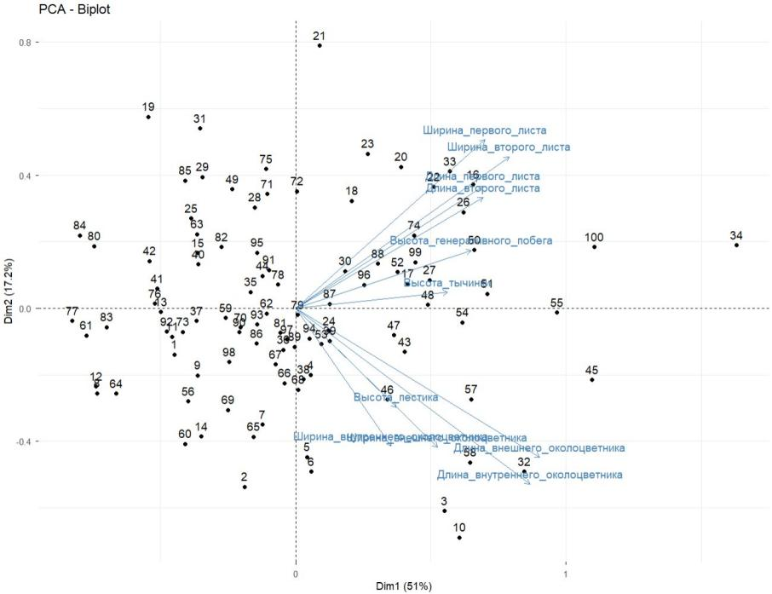
Interpretation:
- The biplot shows PC1 (51.0%) on the x-axis and PC2 (17.2%) on the y-axis.
- Points from different groups show partial separation along PC1.
- Groups with high PC1 scores cluster on the right side; others cluster on the left.
- The loading vectors (arrows) indicate that all variables point roughly in the same direction, suggesting PC1 represents overall size (all traits increase together).
- Variables with longer arrows (e.g., leaf lengths, perianth lengths) contribute more strongly to PC1.
Figure 2: PCA biplot with observations coloured by group, showing group labels.
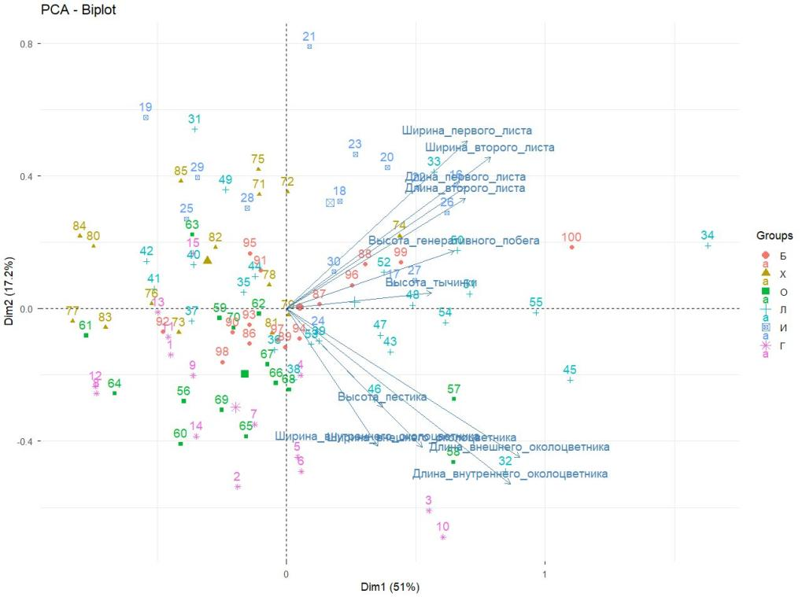

3.3 PCA Biplot – with 95% Confidence Ellipses
Figure 3: PCA biplot with 95% confidence ellipses for each group.
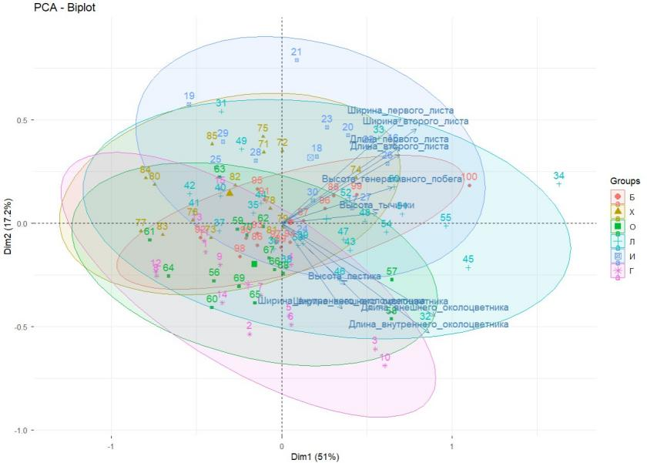
Interpretation of ellipses:
- Group separation: The ellipses for different groups show limited overlap, suggesting the groups differ in their morphological characteristics.
- Ellipse size: Groups with smaller ellipses (e.g., Group G, L) have lower within-group variability (more homogeneous). Groups with larger ellipses (e.g., B, X) show greater morphological diversity.
- Ellipse position along PC1: Groups positioned to the right (positive PC1) have larger overall size. Groups on the left (negative PC1) have smaller overall size.
- Overlap patterns: Where ellipses overlap (e.g., between groups I and B), the morphological differences are not statistically distinguishable.
- Groups identified: B, X, O, L, I, G (corresponding to different populations, treatments, or species).

4. Interactive 3D PCA Biplot (PC1, PC2, PC3)
Figure 4: 3D biplot showing PC1, PC2, and PC3 with loading vectors (arrows).
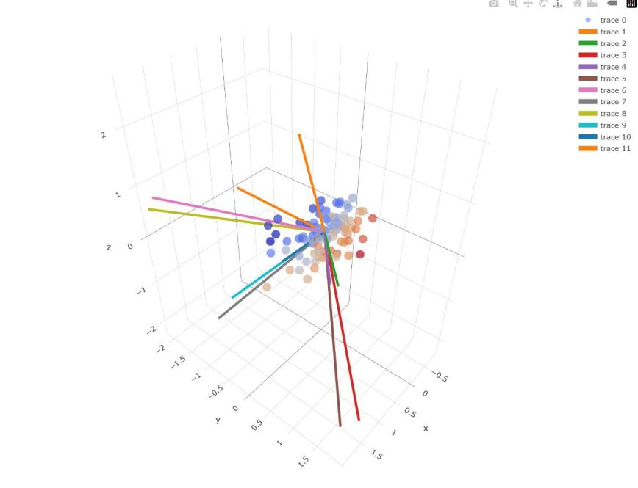
Component | Interpretation
PC1 (x-axis, 51.0%) | Overall size – all variables point in the same direction
PC2 (y-axis, 17.2%) | Shape contrast (e.g., leaf shape vs. floral traits)
PC3 (z-axis, 10.3%) | Additional shape variation (e.g., stamen-pistil ratio)

Observations from the 3D plot:
- The 3D view confirms that groups separate primarily along PC1.
- Some groups that appeared overlapping in 2D may be better separated when PC3 is considered.
- Loading vectors (arrows) in 3D show all variables have positive loadings on PC1, confirming the size interpretation.
- The second and third axes reveal subtle shape differences not captured by PC1 alone.

5. Summary of Findings
Question | Answer
Which traits are strongly correlated? | Leaf lengths with leaf lengths; perianth lengths with perianth lengths; stamen height with pistil height. All positive correlations.
What does PC1 represent? | Overall size – all morphometric traits increase together along PC1 (51% variance).
What does PC2 represent? | Shape contrast – likely between leaf dimensions and floral organ dimensions (17% variance).
How well are groups separated? | Groups show partial separation along PC1, with ellipses overlapping for some pairs but not others.
Which groups are most distinct? | Groups on opposite ends of PC1 (large-sized vs. small-sized) show the clearest separation.
What does the 3D plot add? | PC3 provides additional resolution for groups that overlapped in 2D.

6. Conclusion
The PCA of morphometric data revealed:
- Strong positive correlations among most traits, indicating coordinated growth and development.
- PC1 (51% of variance) represents overall size – all variables load positively.
- PC2 (17%) and PC3 (10%) capture shape variation, distinguishing between different morphological patterns.
- Groups (B, X, O, L, I, G) show partial separation in PCA space, with some groups clearly distinct and others overlapping.
- The 95% confidence ellipses indicate that within-group variability differs among groups; some groups are more homogeneous than others.
- The interactive 3D plot confirms that the first three PCs provide a good summary of the data (cumulative 78.5% variance explained).
Final recommendation: The morphometric traits successfully distinguish among the predefined groups, with overall size being the primary discriminating factor. Further analysis (e.g., MANOVA or linear discriminant analysis) could quantify group differences more formally.

7. Appendix – R Code
The complete R script (practice 6 PCA_HW_eng.R) is attached separately. Key functions used:
- decostand(data, method = "range") – min-max normalisation
- cor.test(method = "spearman") – Spearman correlation with p-values
- prcomp() – Principal Component Analysis
- fviz_pca_biplot() – PCA visualisation with grouping and ellipses
- plot_ly() – Interactive 3D PCA biplot

